This group stopped meeting by the fall of 2015 due to frequent travels of one and general moving on in other directions.

Fiddle Faddlers
Photo is St Paul's performance May 23, 2013

Our local fiddle group, the Fiddle Faddlers celebrated World Fiddle Day on May 17, 2014 by performing at St. Paul's for about an hour. The three fiddlers were Ed Bodin. Kathy McKay and Elaine Bollman and were accompanied by guitarist Harvey Rudyk. The residents enjoyed the live music with toes tapping, hands clapping and some even had a chance to get up and dance. Some tunes were old traditional ones like the Tennessee Waltz and Golden Slippers. Some were newer tunes like the Lieutenant Governor's Waltz written in 1997. Everyone had a good time.
The Fiddle Faddlers are a group of adult intermediate level fiddle players.
They try to practice weekly when all members are in town.
They support each other and create a goal to practice towards. They have performed several times.
2015: Two performed at the Music Festival Fiddle session in April.
2014:
May 17 World Fiddle Day performed at St. Paul's
If you want to read more about World Fiddle Day here is a link for more information.
http://www.worldfiddleday.com/
April 16 group and solo entries in the Music Festival

2013:
November 29 St. Paul's 2:00 pm incld Christmas tunes
Sept 28 Culture Days entertained at lunchtime
July 20 Gallery in the Garden performed one hour in 3 gardens
May 23 St. Paul's (5:30pm)
April 16 The Pas Music and Fine Arts Festival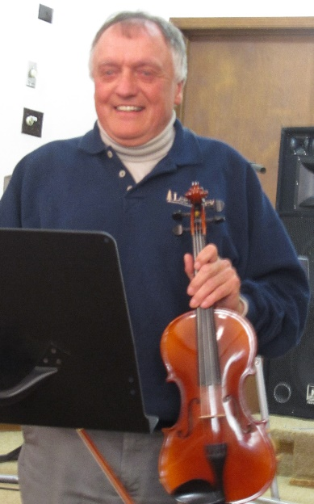
2012:
Sept 30 Culture Days concert (Legion Hall)
April 16 The Pas Music and Fine Arts Festival
March 29/30 Group attended the Bam Jam Fiddle Camp in Bowsman MB.
2011:
Nov. 27 Senior's Christmas Party (Legion)
Nov. 25 St. Paul's 30 minute entertainment
Nov. 20 Music Club Adult recital ( 2 group numbers and 3 solo numbers.)
In 2008-09, the group had five fiddlers but two have moved from town.
Fall 2013 we were joined by a guitarist Harvey Rudyk.
Ed Bodin bodinet@mailme.ca
Kathy McKay dkmckay@mts.net
Elaine Bollman eabollmus@gmail.com

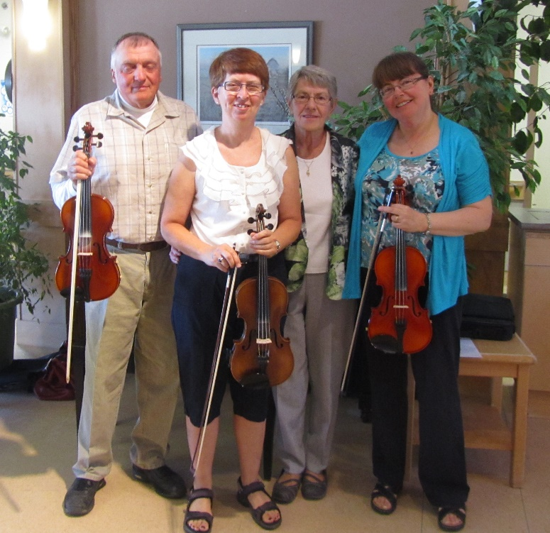Our last performance at St. Paul's with
accompanist Carol Boyes May 23, 2013.
Carol passed away that fall.

2013 04 16 Fiddle Faddlers at the Music Festival

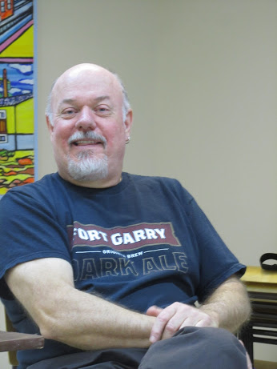

Ron Scott taught beginning fiddle classes around 2007
and in April 2013 gave a Celtic Circle Workshop.
More info on that can be found on an attached page.

